**Group Members:**

Tirumala Reddy Konireddy

Krishna Chaitanya Nalluri

Syamala Reddy Arimanda

Divya Sree Vintha

GESTURE ALERTS PROJECT  
SECOND INCREMENT REPORT

**Project Goal and Objectives**

**Motivation**

From last 5 years,the mobile devices are available for every human in the world where we had experienced a lot of innovation in the areas of Health and Fun Applications. But, every mobile application now a days requires eye contact with a mobile, which makes the handicap people having vision impairment can’t utilize the present day technology. We are motivated to make their daily life easy and more entertaining with the present day technology like Android Mobile device and TI sensor tag.

**Significance**

Our Android Application uses the Texas Instruments sensor tag to makes physically challenged people to convey their emotions using gestures easily to the respective persons with ease, also help them to be fit and having some fun.

**Ex:**

It is hard for a vision challenged person to convey as he is hungry to a person related to Dining department who is incharge of his nutrition as he needs to go right to the nutrition in charge and convey about his hunger or atleast type a text message to him.

Our Application will make ease of all this type of problems for vision challenged people using Accelerometer and Temperature sensor.

**Objectives**

* Email or Text alert service for visually changed people Care Taker’s
* Physical Trainer service to help visually changed people be fit
* Sickness Alerts to Care Taker’s and Doctor’s
* Fun activities for Mental relief and Entertainment

**System Features**

* We are providing a Alert service to Care taker’s of visually challenged people by motion gestures related to feeling hunger, need some water, power short circuit etc., through mails or text messages.
* We also provide a physical trainer application which recommends and instructs some fitness programs based on their Body Mass Index. At the end of the workouts session we will provide him a feedback about his exercise.
* We are providing a sickness alert service to physician and doctor in charge regarding the person using temperature sensor.
* We are also providing some entertainment with fun activities for a visually challenged person using TI sensor.

**Activity Recognition Scenario and Data Collection**

**Devices/Sensors:** The CC2541 Sensor tag developed by Texas Instruments is being used to listen or detect the user gestures required for the Application.

This device is capable to detect and send data related to six senses.

* The “IR temperature Sensor” is used to take the body temperature values of users.
* The humidity factor in the environment is detected by the Humidity Sensor.
* The pressure control points are detected by the pressure sensor.
* The device also supports accelerometer data depending on the weight factor experienced by the sensor.
* The Gyroscope feature of this device measures the orientation based on principles of angular momentum.
* The Magnetometer in this device is used to sense the magnetic field and its strength in the surroundings.

This device is enabled with low energy bluetooth data transfer, which is used to collect sensor data sensor tag from Android Mobile device.

**Reference:**

<http://www.ti.com/tool/cc2541dk-sensor?keyMatch=cc2541%20sensor%20tag&tisearch=Search-EN#descriptionArea>

**Data Collection:**

We are considering two sensor devices namely BLE Sensor Tag and TI Chronos Watch for our project.

Data Collection from BLE Sensor Tag:

We had developed a Android Application to test the sensor tag services like below,

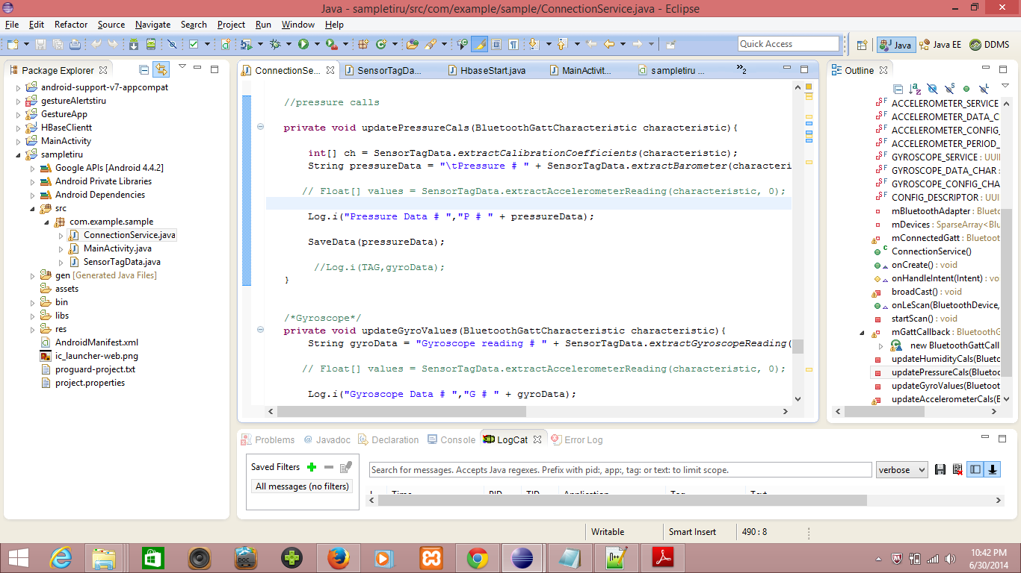

We had collected the following Humidity, temperature, location and accelerometer services using BLE Senor tag for applying to our application.

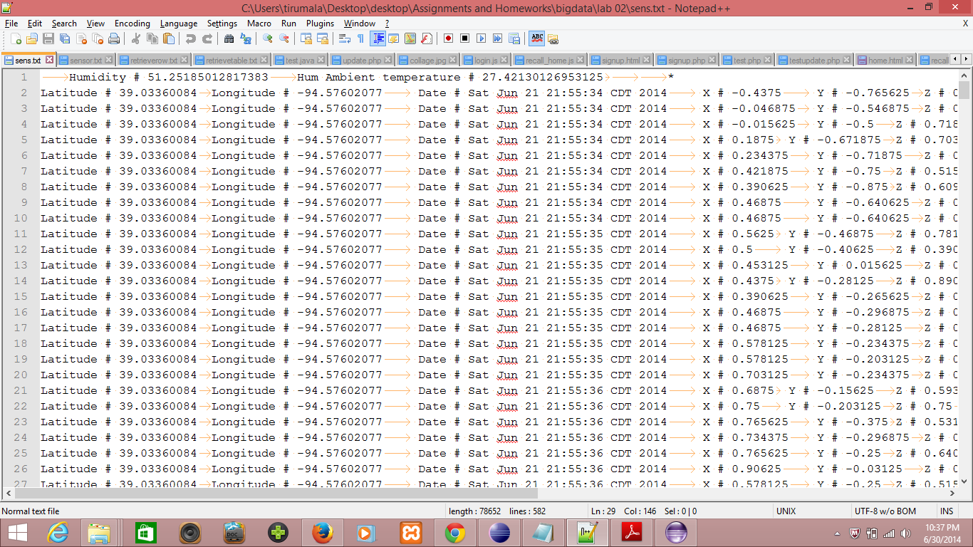**BLE Sensor Tag Data**

We had developed a web service to upload all this data into HBASE server for using this data to train gestures as follows,

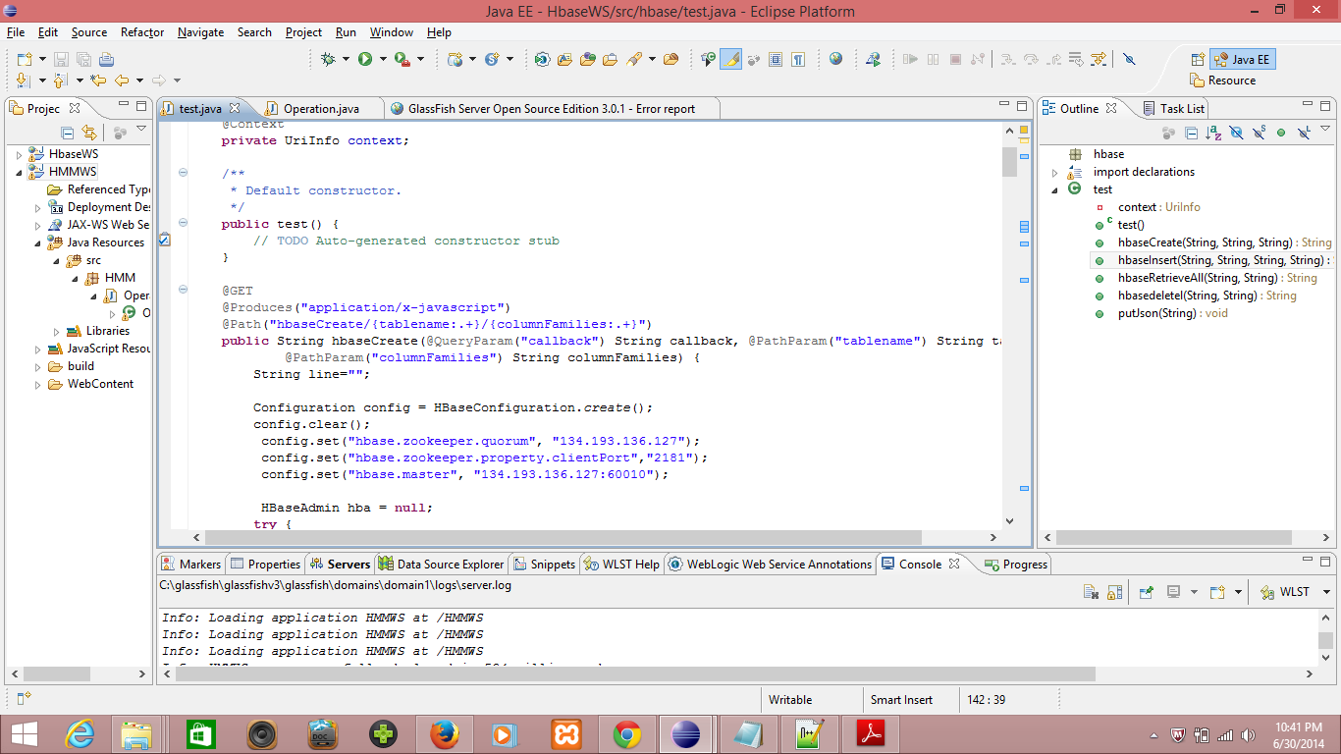

We had created a table in HBASE with our groupname Group1SensorTable,

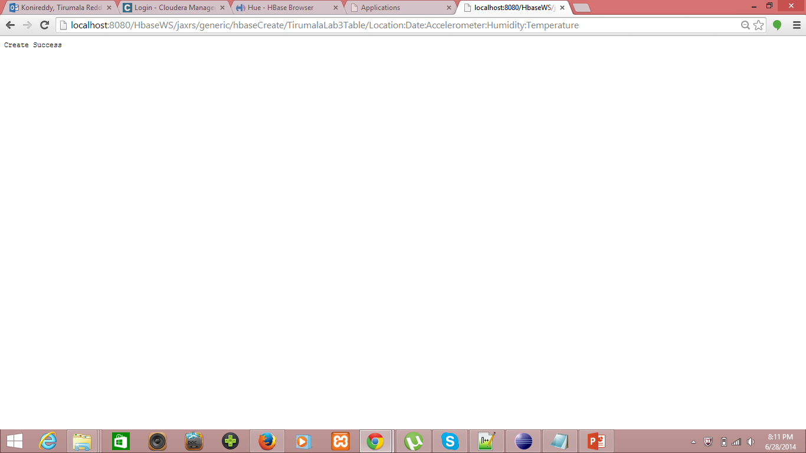

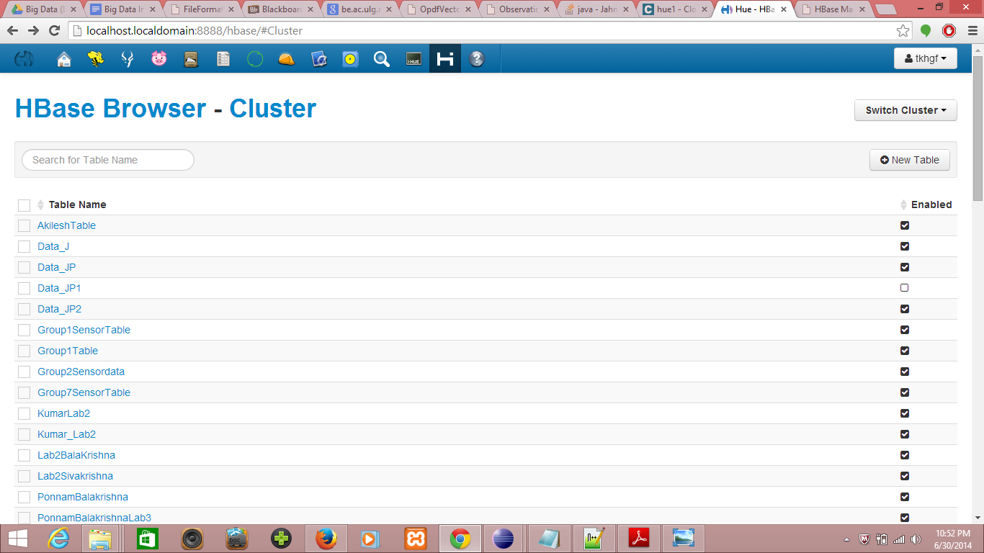

We had inserted the sensor data into the text file as follows, using webservice

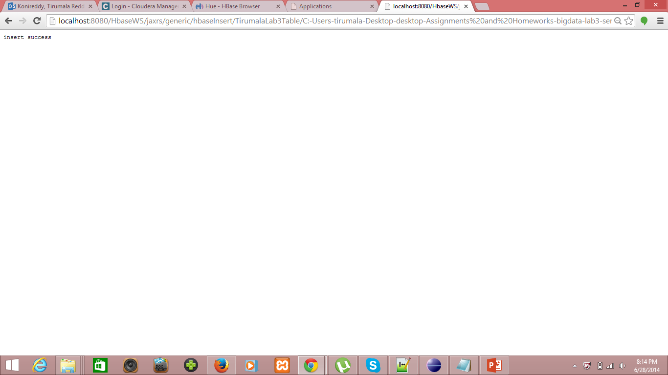

The data uploaded to Hbase can be viewed as follows,

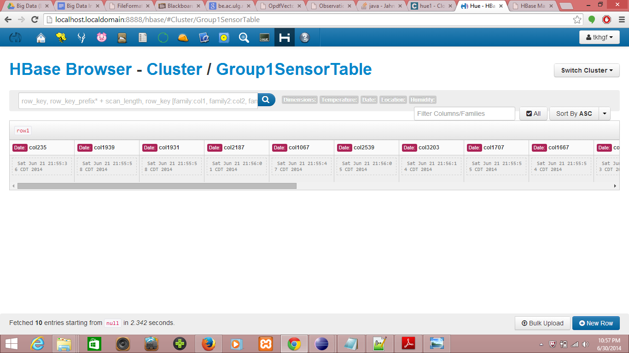

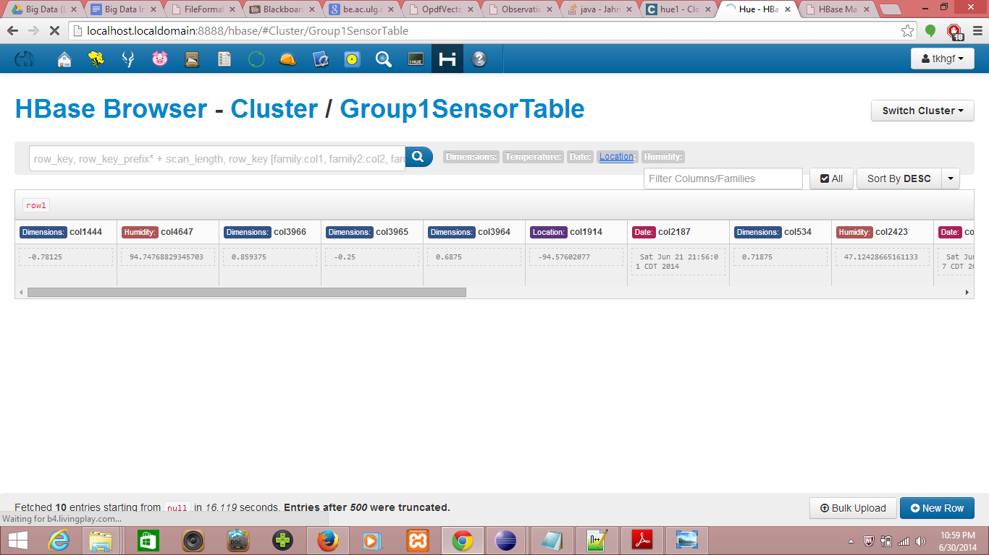

We had successfully accessed data stored in Hbase on retrieval,

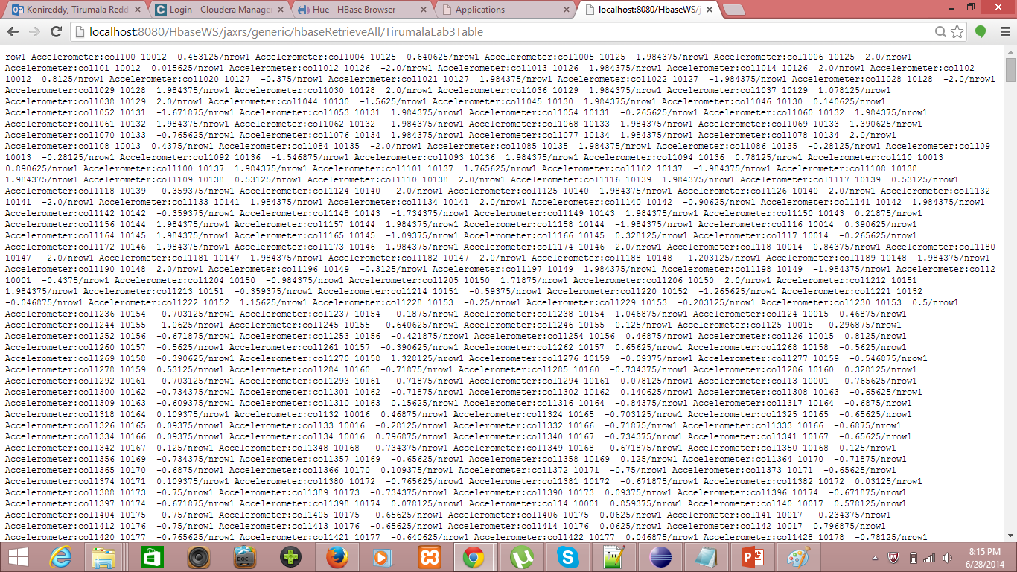

Data Collection from TI Chronos Watch:

We had used the Chronos Flying Mouse Application to collect data from TI Chronos watch as follows,

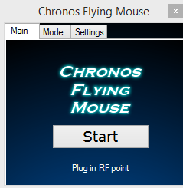

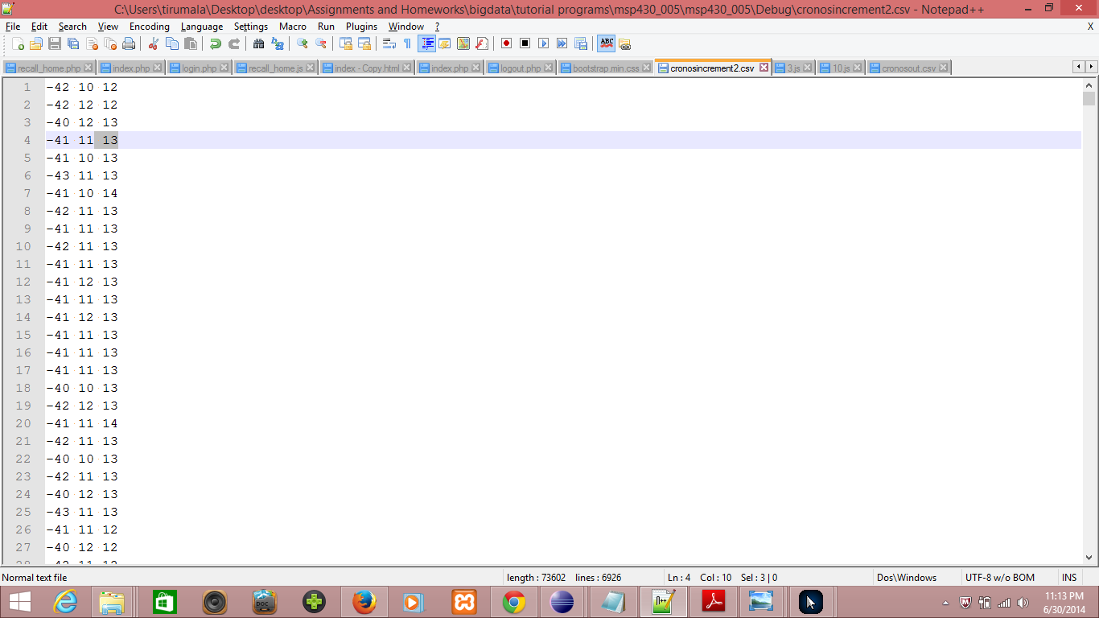

I had parsed this file into comma seperated file as below,

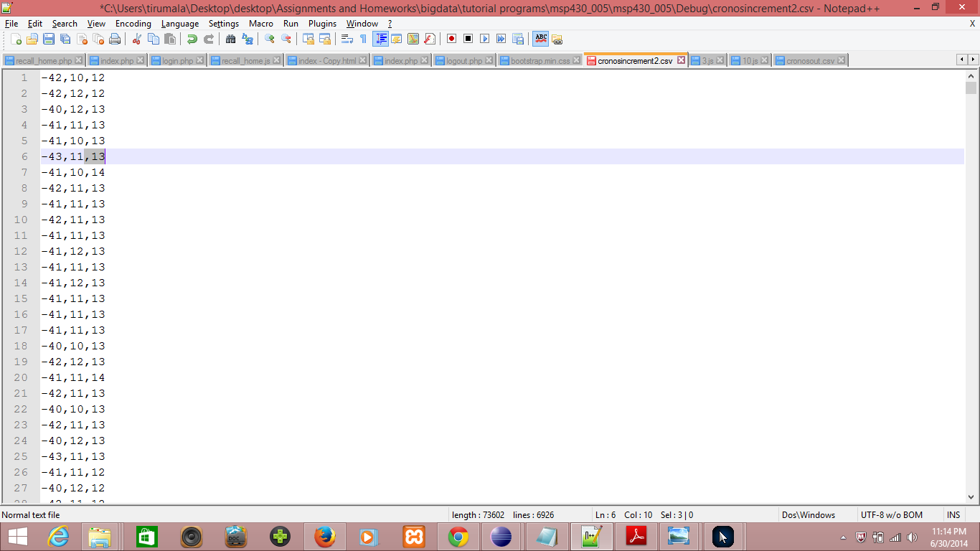

I had created a graph to see the plot of gesture data collected using TI chronos watch as below,

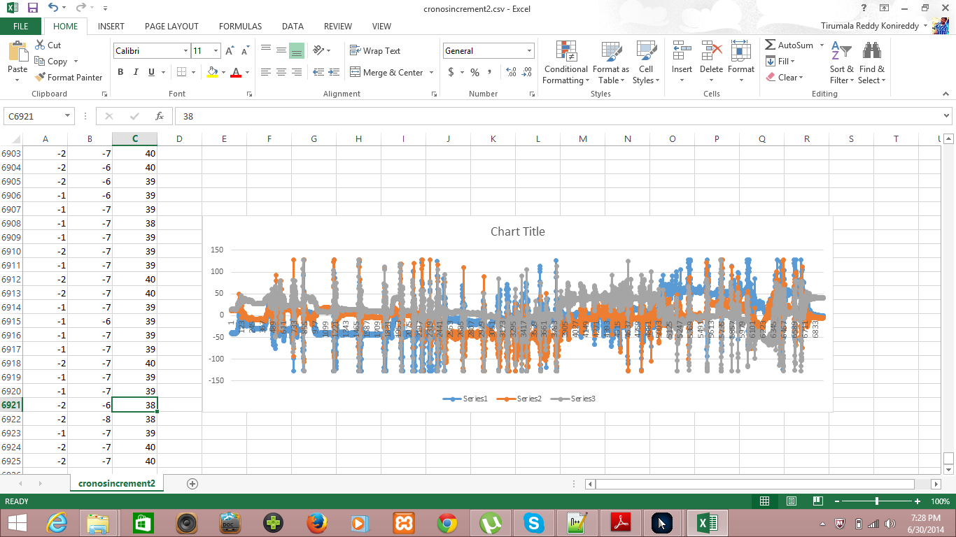

Using graph we identified the data inputs related to a gesture made while data collection, and filtered those samples using start and end as below.

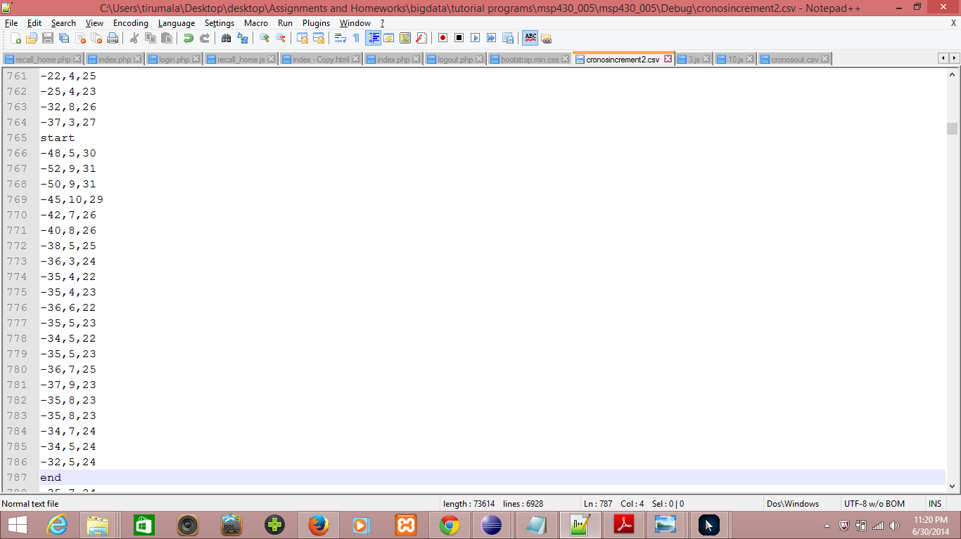

Then, I parsed this file into a sequential file as below.

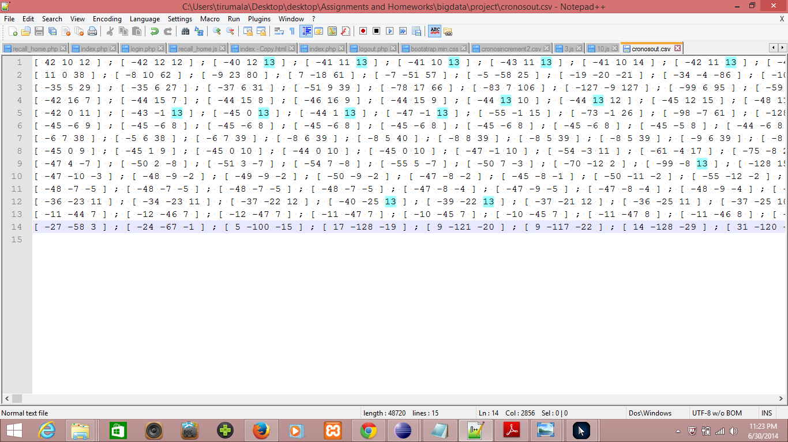

We had developed a webservice using be.ac.ulg.montefiore library to train and test all the gesture data as follows,

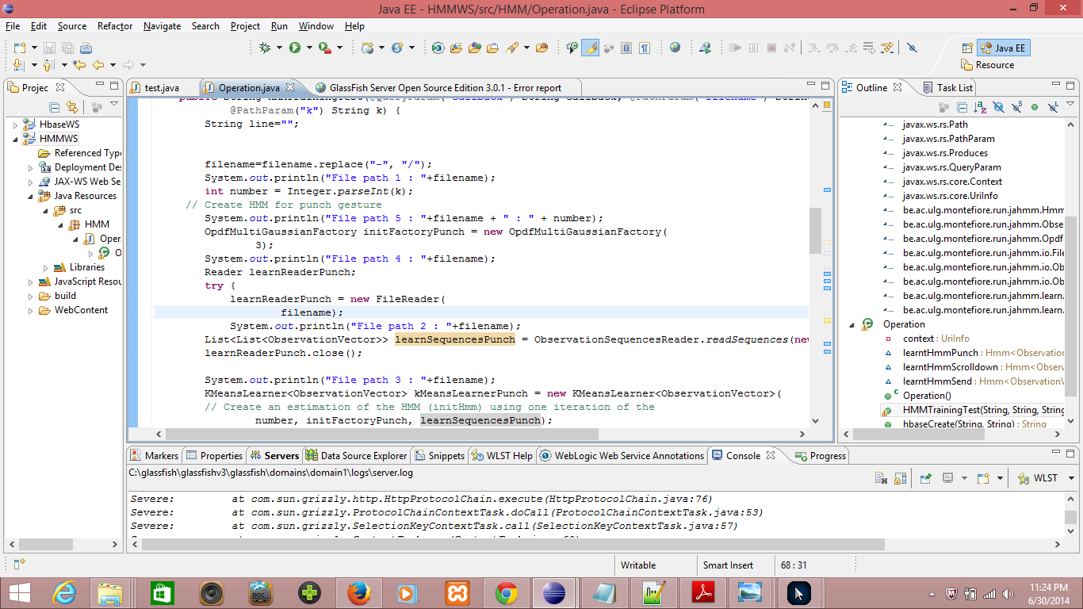

We got so many errors first and we had debugged a lot and unfortunately we got struck here with a error **Severe: be.ac.ulg.montefiore.run.jahmm.io.FileFormatException: Line 2: Number or ']' expected** while training.

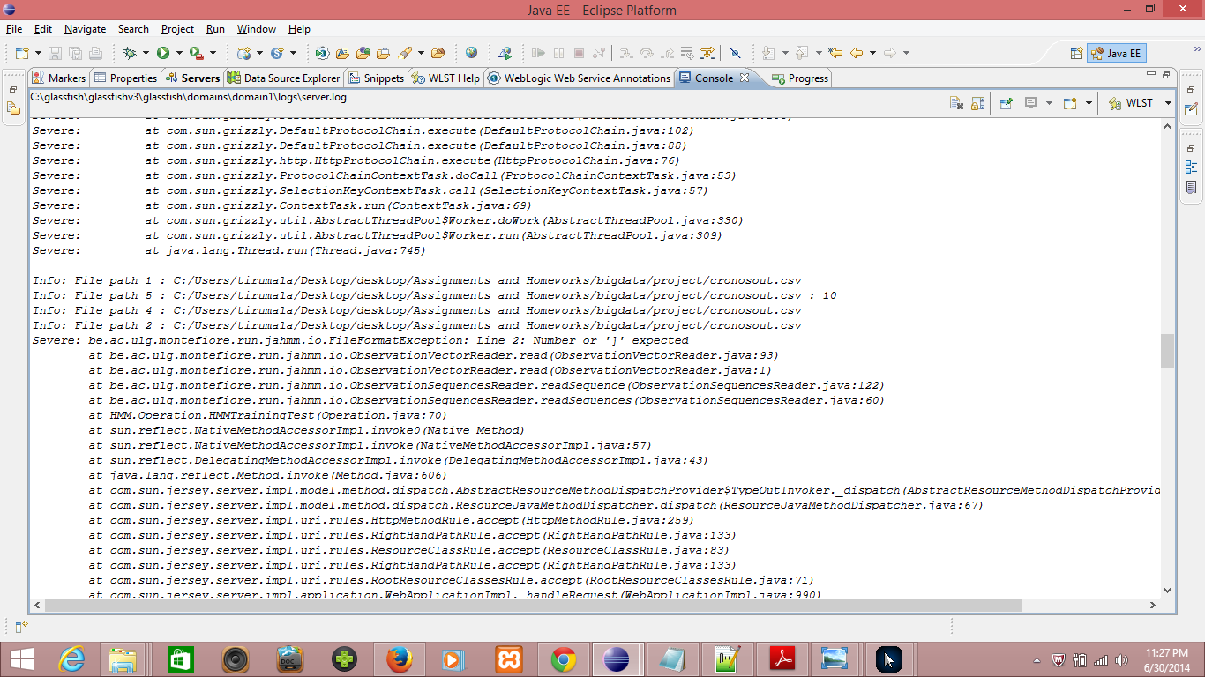

We are looking forward to debug this issues for training the gesture data collected using TI Chronos Watch and apply them in our application to trigger necessary intents.

**Motion/Activity Model:**

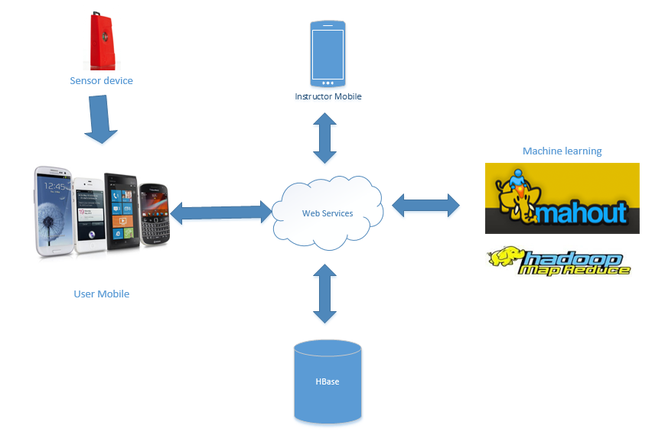

Architecture of the application

**Analytical Tasks:**

* The data is collected from sensor to the mobile as a text log file.
* This log file is automatically uploaded into the HBase using web Service.
* Machine learning algorithms of R / Mahout uses the data in Hbase for providing Alert services and Physical trainer services fro Accelerometer and Temperature data.

**Design of Mobile Client**

**Features, Styles, Technologies, GUI**

* We are providing a Alert service to Care taker’s of visually challenged people by motion gestures related to feeling hunger, need some water, power short circuit etc., through mails or text messages.
* We also provide a physical trainer application which recommends and instructs some fitness programs based on their Body Mass Index. At the end of the workouts session we will provide him a feedback about his exercise.
* We are providing a sickness alert service to physician and doctor in charge regarding the person using temperature sensor.
* We are also providing some entertainment with fun activities for a visually challenged person using TI sensor.

We have planned to work on the GUI from Second Increment. In this increment we have created the basic GUI model which can be altered depending on our requirements further.Firstly, the home page includes pictures which shows a small glance of our application which depends on gestures to express human feelings. The bottom two images are aligned for some gaming activity and other alert services which can be controlled by gestures we train in our system.

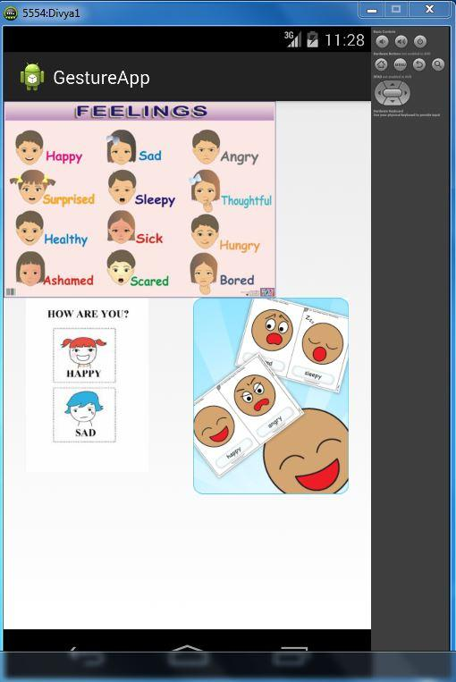

The Bottom right image, on click goes to a game activity which we are working on. The activity content is yet to be developed depending on the game. Here is a snapshot of that activity.

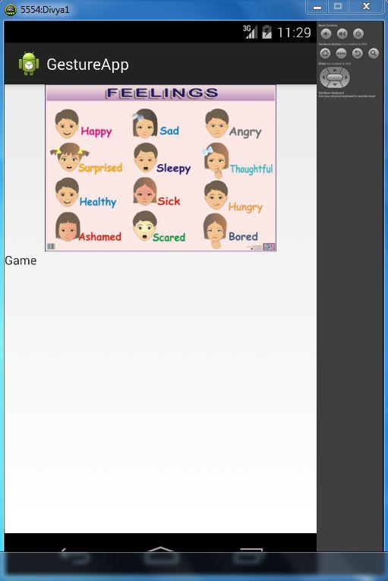

The other image in the main home page can give an alert to the user depending on their mood and feelings. Here is a sample sanpshot for that activity which is yet to be developed for the alert systems.

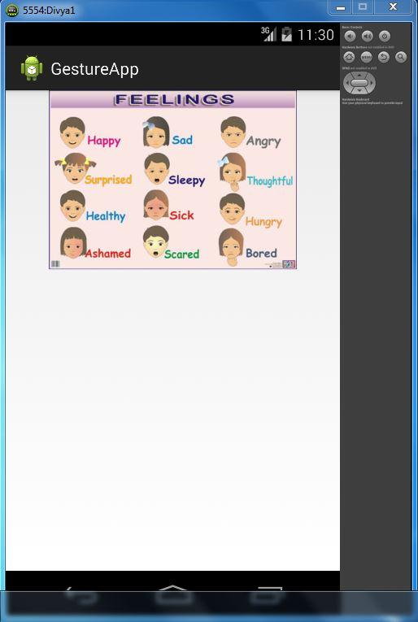

The front end is mainly based on Android and the code we developed to work on this uploaded in the github. Here is a snapshot of the working code.

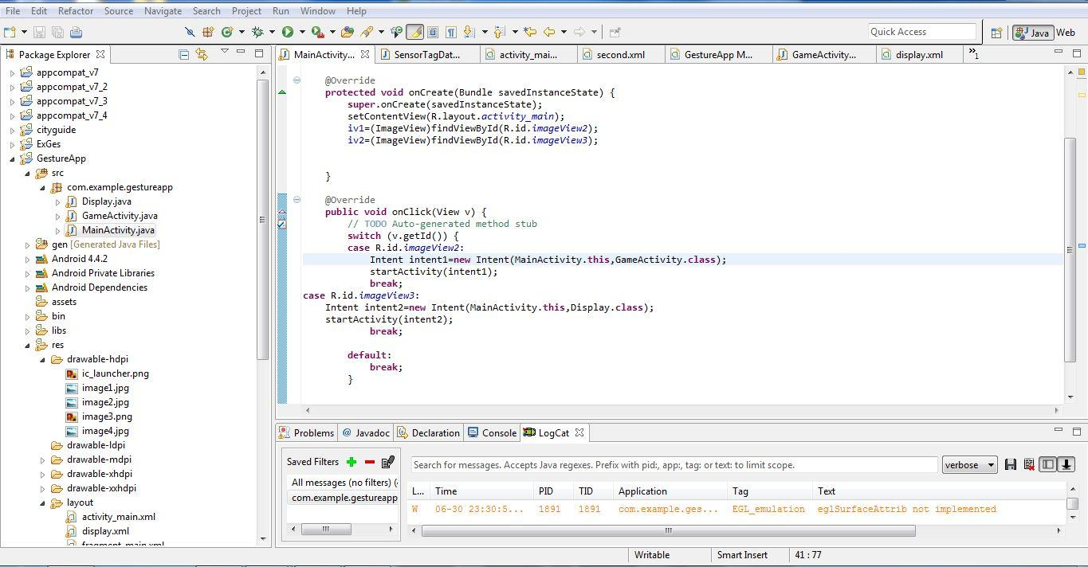

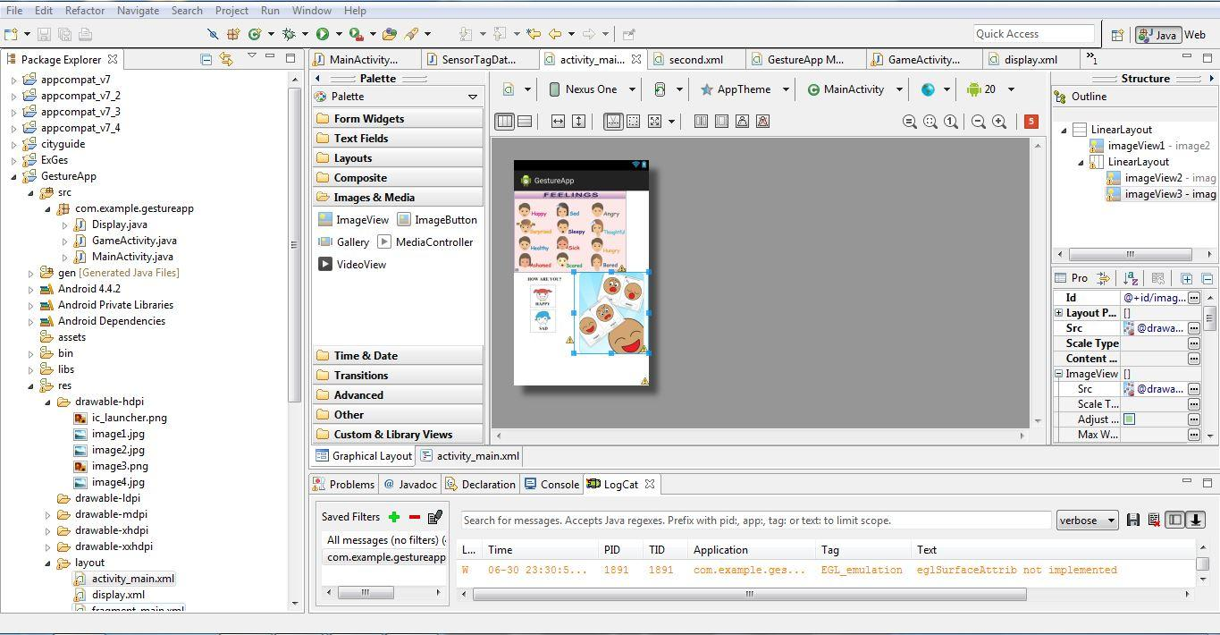

**Related Work:**

Many speech to text applications are available to store the notes or messages. Our application takes the input using gestures and alerts the trainer with their requirement.

https://play.google.com/store/apps/details?id=com.khymaera.android.listnotefree

The temperature sensor application gives the readings of temperature in specified scales. Our application alerts the user for any unusual temperatures of the user.

https://play.google.com/store/apps/details?id=com.dexterltd.temprature_sensor_lite

**References:**

<http://www.ti.com/tool/cc2541dk-sensor?keyMatch=cc2541%20sensor%20tag&tisearch=Search-EN#descriptionArea>

<http://en.wikipedia.org/wiki/Gyroscope>

<http://en.wikipedia.org/wiki/Magnetometer>

<http://en.wikipedia.org/wiki/Accelerometer>

<https://play.google.com/store/apps/details?id=com.dexterltd.temprature_sensor_lite>

<https://play.google.com/store/apps/details?id=com.khymaera.android.listnotefree>